**ENGI 1331 Project 4 Spring 2016**

**MATLAB Engineering Problems in Chemical Processes, Statics, and Circuit (Due @1159am on Wednesday, April 22, 2016)**

**For any questions regarding this project please post queries to the ENGI 1331H discussion board.**

**I. Overview**

In this last MATLAB project, you will solve problems relating to three different engineering classes to understand how to use MATLAB in conjunction with setting up the systems of equations for each system. Included in the project folder are useful documents that will help you understand the concepts behind each of the problems in this project. Many of the concepts will be foreign to you, so don't hesitate to come to office hours or ask questions on the discussion board about the concepts if you're finding them challenging. This is an application of your knowledge of MATLAB, deciphering a problem and using the engineering process to create a solution.

**II. Procedure**

**Question: What amount of “collaboration” with fellow students is allowed?**

Answer: You are encouraged to discuss verbally the project with other students. You can brainstorm together solution approaches, and you can teach each other how to do things with MATLAB. However, allowed collaboration ends with this verbal discussion. At no time can you copy work others have done, or have someone else do any of the work for you, or do any of the work for someone else. “Copying” includes obtaining an electronic copy, or simply looking over shoulder and writing down the MATLAB commands, or exchanging verbally the MATLAB commands. Everything in the MATLAB script file itself must be your work, and your work alone. If you need more help, ask your proctor or instructor for assistance.

**Question: Can I use MATLAB functions or operations we have not covered in class?**

Answer: In this particular project you can use explicit loops (for or while) or the “If” statement. MATLAB’s implicit loops (array operations & intrinsic functions) are allowed.You cannot use anything from the MATLAB toolboxes (e.g., the symbolic toolbox). Only the standard/basic MATLAB package is allowed.

Create a folder entitled uuuuup4 where uuuuu are all the characters of your cougarnet username. As you work on this project, save all of the specified files in this folder. This should be set as your current working directory in MATLAB. When finished, you will compress the folder and submit it to Blackboard Learn as instructed in the document “Turning in Your Work” under the Assignments section.

Begin by creating a script file named main.m. This file should begin with a title comment that includes your name, email address, and cougarnet ID. This information should also be displayed in the command window.

Additional comments should briefly describe the project and the important parameters. Be sure to put *clear, clc,* and *close* all as the first executable instructions in your script before the title display. (You might also want to clear some specific variables (NOT clc) at the start of each new problem.)

The computations will be divided into tasks described below. Work the problems and tasks in the order given below. Preceding each task, provide a comment with the task number, e.g. “Task 1”, followed by suitable explanatory comments of what the task involves. The task number and explanatory comments should also be displayed in the command window when your script file is run. This documentation is required! In other words, both your script and your output must be easy to read with each section well delineated.

Some of the tasks will require you to produce plots. Be sure you follow the instructions—display an appropriate "prompt" in the command window after your plot command (e.g., "See Figure 1 for plot showing frequency response. Press any key to continue.”), followed by the pause command. Put semicolons at the end of most command lines so that only those lines you specifically need to display will be displayed. Any text displayed in you command window should be done either using some sort of display or write command.

In the Project 4 assignment on the ENGI 1331 website, in addition to this assignment document you will find plain text files containing data to be loaded in some of the tasks of this assignment. Copy these files to your uuuuup4 directory, as that is the first place that MATLAB will look for them. However, your solution must be kept sufficiently general so that if these values are changed, or a file with different values is loaded, the script will still execute correctly—without anybody making additional changes. We will execute your script with a different set of values!

Your M-file should have comments and blank lines as shown in this example:

% ENGI 1331 Project 4 – your name – your cougarnet ID

clc; close; clear;

disp('ENGI 1331 Project 4 – your name – your cougarnet ID');

% Problem 01 Ammonia Production

disp(' '), disp(' '), disp('Problem 01 Ammonia Production), disp(' ');

% Task 1 – Applying Mass Balances;

disp(‘Task 1 – Applying Mass Balances’);

**Problem 1 – Ammonia Production**

In this problem, you will use mass balance equations to generate various plots in order to graphically analyze an ammonia production process, then use these graphs to provide recommendations on how to optimize the system. Use the support documentation “Intro Chem Processes.pdf” to familiarize yourself with concepts covered in the problem.

**Task 1 – Applying Mass Balances**

Nitrogen (N2) and hydrogen (H2) are fed to the ammonia plant in stoichiometric proportions, along with an inert gas (I). The recycle stream containing the same three species is combined with the fresh feed, which is then fed to a low single-pass conversion reactor. The reactor output is fed to a condenser in which ammonia is removed as the condensate. The gas exiting the condenser containing nitrogen, hydrogen, and inert is split into two fractions with the same composition: one is removed as the purge stream, and the other is the recycle steam. Nitrogen and hydrogen are in stoichiometric proportions in every stream containing the two. The flowchart shown below provides an overview of the process:

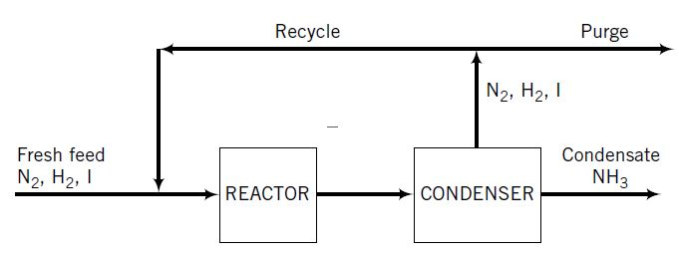

Let XI0 be the mole fraction of inert gas in the fresh feed, fsp be the single-pass conversion of nitrogen (and of hydrogen) in the reactor, and yp be the fraction of the gas leaving the condenser that is purged (mol purged/mol total). By taking a basis of 1 mole in the fresh feed, the flowchart can be fully labeled as shown below:

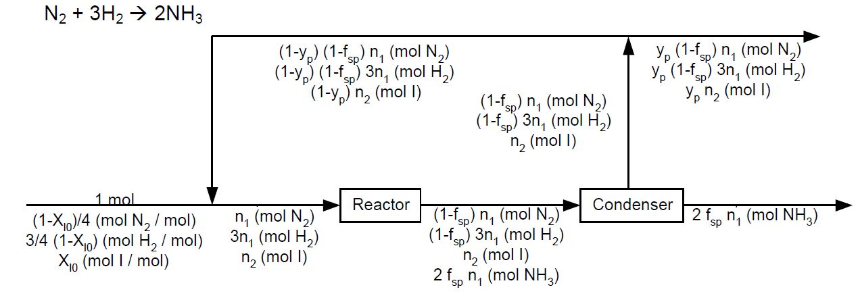

Assume that the values of XI0, fsp, and yp are given, on a sheet of paper write mass balance equations which can be used to solve for the total moles fed to the reactor (nr), moles of ammonia produced (np), and the fraction of overall nitrogen conversion (fov). The overall fractional conversion of ammonia is defined as the following:

$$f_{ov}=\frac{moles of N_{2} fed-moles of N_{2} purged}{moles of N_{2} fed}$$

Create a user defined function in MATLAB which will take three inputs XI0, fsp, and yp and output the variables nr, np, and fov. Prompt the user to input values for XI0, fsp, and yp. Use their input to calculate the values for nr, np, and fov. Design your function to use element-by-element operations so that it may accept scalars or vectors as input variables.

**Task 2 – Graphically analyzing the system**

Hold the variable XI0 and fsp constant at the previous values from task 1. Allow yp to vary between .01 and 1. Use your function to generate a plot of np versus yp, where yp is on the x-axis. Label this plot Figure 1 and use appropriate axis labels. Display in the command window the observed relationship between yp and np.

Hold the variables XI0 and yp constant at the previous values from task 1. Allow fsp to vary between .01 and 1. Use your function to generate a plot of np versus fsp, where fsp is on the x-axis. Label this plot Figure 2 and use appropriate axis labels. Display in the command window the observed relationship between fsp and np.

Hold the variables fsp and yp constant at the previous values from task 1. Allow XI0 to vary between 0 and 0.99. Use your function to generate a plot of np versus XI0, where XI0 is on the x-axis. Label this plot Figure 3 and use appropriate axis labels. Display in the command window the observed relationship between XI0 and np.

**Task 3 – Optimizing the system**

Based on your graphical observations from task 2, what recommendations would you give in order to optimize the production of ammonia? Which of the three independent variables XI0, fsp, and yp would you maximize and which would you minimize? Provide a rational explanation for the observed relationship between the three variables. Calculate the theoretical maximum production of ammonia. Clearly display all your answers and explanations in the command window.

**Problem 2: Circuit Analysis**

In this problem, you will use Kirchoff’s laws to analyze a circuit in order to calculate the currents in their respective resistors and find the allowable limits for voltage using a system of linear equations. Use the support documentation “Circuit_Analysis_PartII.pdf” and “Circuit_Analysis_PartIII.pdf” to familiarize yourself with concepts covered in the problem.

**Task 1: Applying Kirchoff’s Laws**

A closed circuit is shown in the diagram below. There are two voltages, V1 and V2, with units of volts; three currents, I1, I2, and I3, with units of ohms; and three resistors, R1, R2, and R3, with units of amperes.

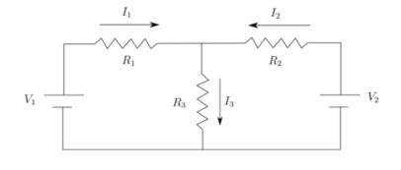

Before you begin using MATLAB, you will need to apply your knowledge of Kirchoff’s Laws to create a system of linear equations for the circuit above. You will need these equations to solve for the currents, I1, I2, and I3.

The VR.m file in the Project 4 assignment has values for V1, V2, R1, R2, and R3. Use this file to create the variables and display them in the command window. (Do not hardcode the values from the VR.m file. We will use a different file to grade your solution.) Using the set of linear equations you made earlier, create a user-defined function named CircuitSolver that will solves for and returns the currents I1, I2, and I3 when inputting the values for V1, V2, R1, R2, and R3.

Using printmat(), display each voltage (1st column), resistance (2nd column), and current (3rd column) in a 3x3 matrix with headers (see formatting below). You may leave the spot for V3 as 0 as shown below.

V1 R1 I1

V2 R2 I2

0 R3 I3

**Task 2: Current Effects on Voltage**

Each resistor is rated for a maximum current of 1 amp. Using your CircuitSolver function created in Task 1, find both the minimum and maximum limits for V2. V1, R1, R2, and R3 are the same as in Task 1. Clearly display your results in the command window.

**Task 3: Resistance Effects on Voltage**

Now, you are going to investigate how the resistance in R3 limits the allowable range of the voltage for V2. Let the value of R3 range from 15-115 A. Once again using CircuitSolver, find the minimum and maximum voltage for each different resistance value of R3, as well as the average voltage range and display these values in the command window.

On one graph, plot the maximum and minimum values with respect to resistance. On the graph, include a legend labeling each curve by their color, proper axis labels, and a descriptive title. Interpret the graphs and answer the following question in the command window: What is the relationship between voltage and resistance? What would you look for in optimizing the voltage range for the circuit?

**Problem 3 – Static Equilibrium**

In this problem, you will apply the principles of statics to evaluate the system shown below in Task 1. Use the support documentation “Fun-with-Statics.pdf” to familiarize yourself with concepts covered in the problem.

**Task 1 – Setting up the problem**

Consider a beam connected to a wall held in static equilibrium by a cable with tension T. The angle between the beam and the rope is θ, the length of the beam is L, the distance to the top of the cable is D, the mass of the beam is m, acceleration due to gravity g, and the reaction forces of the wall in the x direction and y directions are Fx and Fy, respectively. The image below is a depiction of the beam:

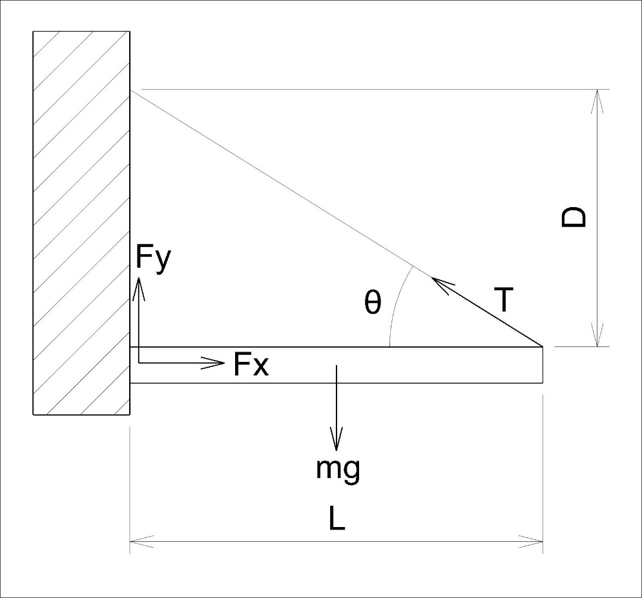

Before you can solve this problem in MATLAB, get out a sheet of paper, draw a free body diagram, and apply the principles of statics to set up three linear equations: one for the x direction, one for the y direction, and one for the moments. Arrange your linear equations in matrix-vector notation so that the three equations can be solved simultaneously for Fx, Fy, and T.

Take g to be constant at 9.8 m/s2, and prompt the user to input values for m, L, and D. Use the matrix-vector notation to solve the system of linear equations for Fx, Fy, and T. Clearly display these values in the command window.

**Task 2 – Plotting the forces**

For this task, you are going to create two graphs arranged in a subplot. The first plot will include Fx, Fy, and T as a function of the m, where m is between 0 and 500 kg. The second plot will show Fx, Fy, and T as a function of L, where L is between 0.1 and 20 m. All three forces should be shown on the same graph for both plots. Include a legend and appropriate axis labels for both graphs. Interpret the graphs and answer the following question in the command window: How is each force affected by the change in m and L? Which forces are affected most and least? Why?

**Task 3– Maximum weight**

Suppose that the cable is rated for a maximum tension of 5000 N. Find the maximum value of m assuming all the other variables stay the same as in Task 1. Clearly display this value in the command window.

**Task 4 – Length vs. Maximum Weight**

Now, we want to investigate how L affects the maximum value of m, given that the cable is still rated for 5000 N. For the range where L is between 0.1 and 20 m, calculate the maximum weight. Generate a smooth plot of the maximum weight versus the length, where the maximum weight is on the x-axis. Give the graph a proper title and axis labels.